**Experiments on Different Virtualization Technology**

**2 Different Virtualization Technologies: Detailed configurations**

1. Docker:

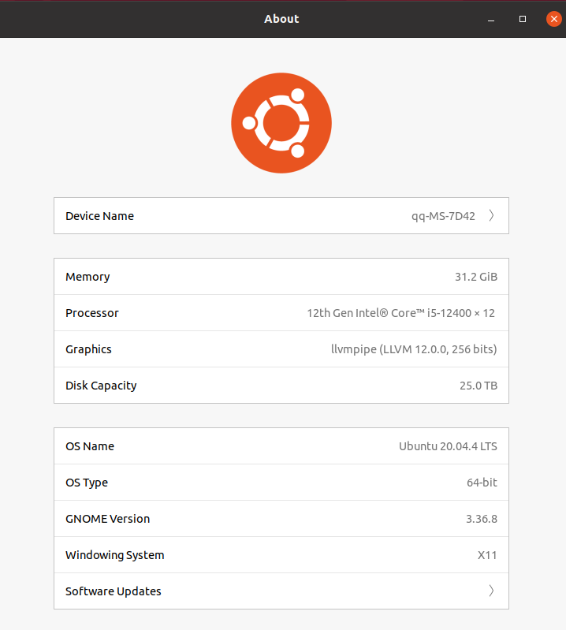

1. QEMU(UTM):
2. Architecture: ARM64 (aarch64)

System: QEMU 6.2 ARM Virtual Machine

CPU Cores: 2

Memory: 4.0 GB

Disk: 9.21 GB

**3. Enable QEMU VM/QEMU commands:(UTM back up)**

I have tried using the given link in the homework instruction and the example set of code that may be useful, but they don’t work. Some of the arguments in the set of codes such as -drive id=hd0 -device netdev=net0 can’t be found.

* 1. 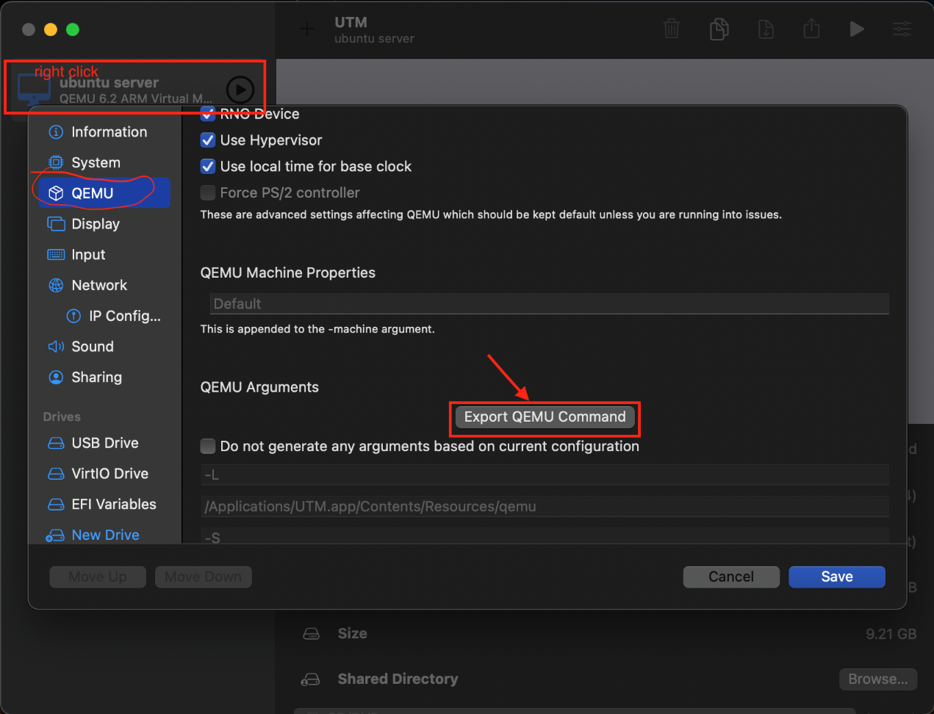
  2. 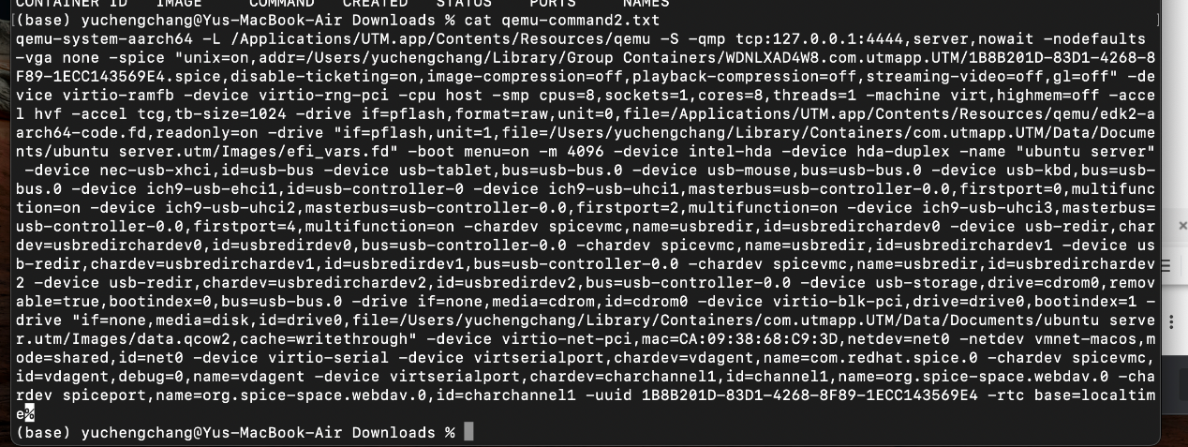

**4. Enable Docker Container.**

Operations to manage docker container:

docker run : build new container and execute

docker kill: Delete the executing container, but the container still exists

docker rm: Remove the container, the container is gone forever.

docker start: activate the container

docker stop: stop the running container

docker ps : show running docker

**5. Screenshots that show my docker and qemu running environments exist and sysbench is installed.**

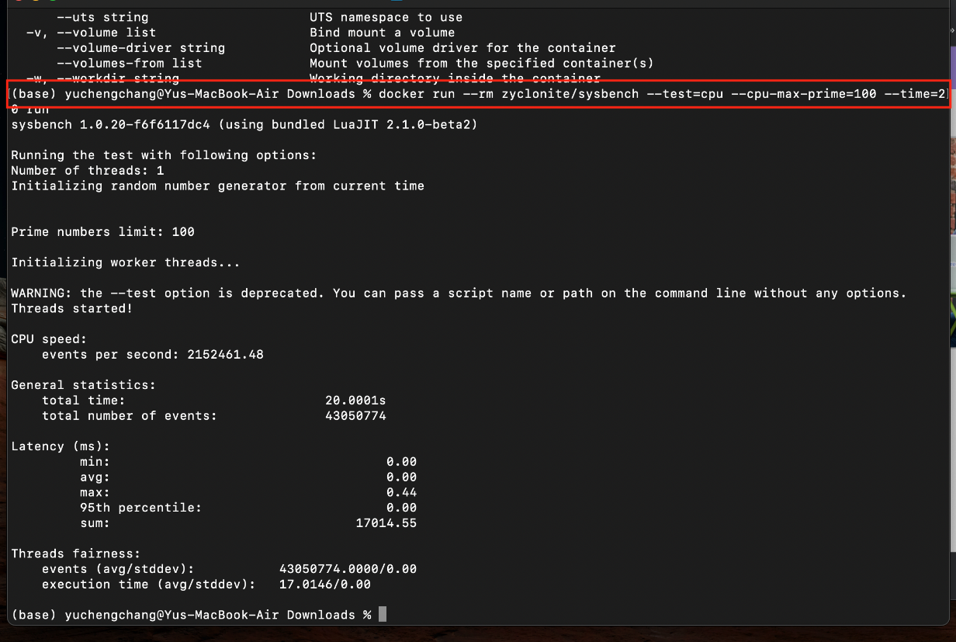

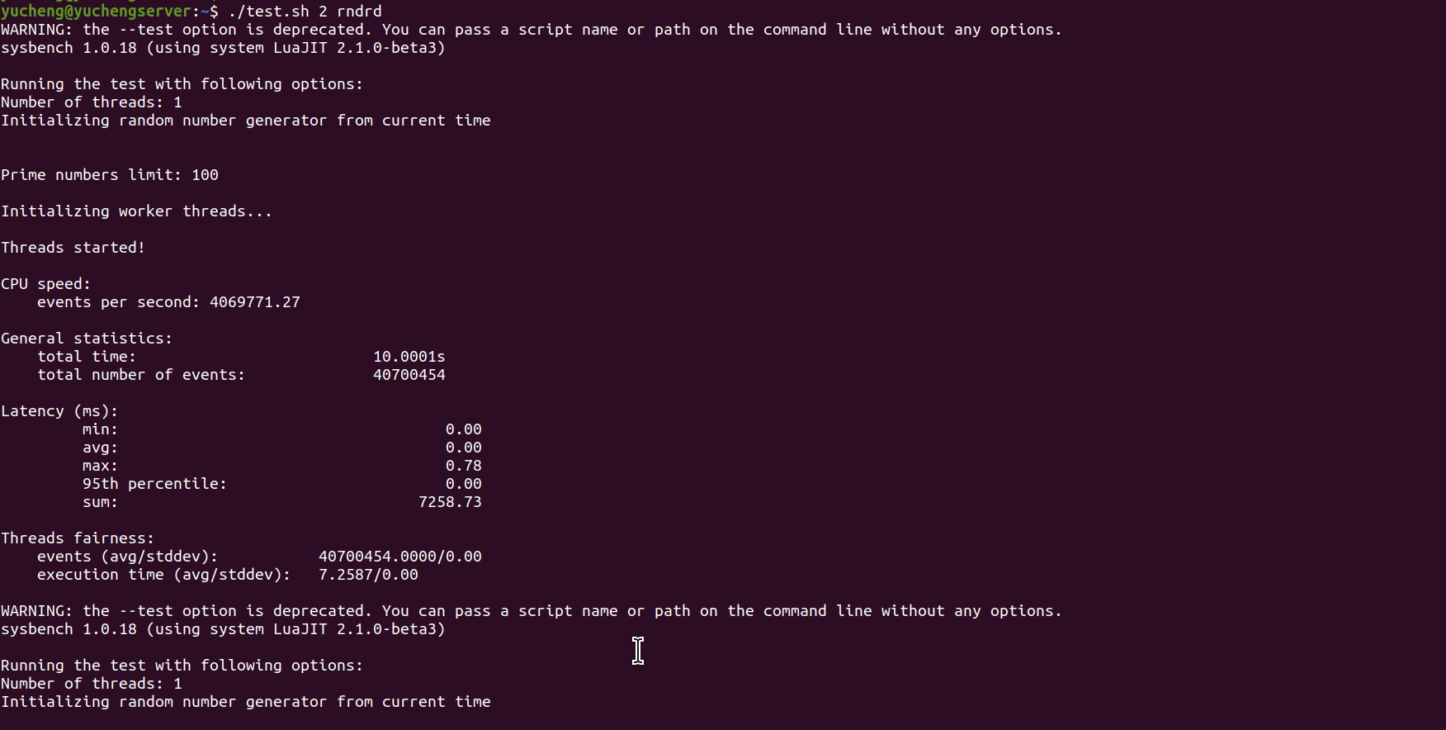

**6. Testing performance on Docker and QEMU.**

**6.1 Three different scenarios for docker:**

**6.1.1 Test mode :** **CPU**, -cpu-max-prime = 100000000

|  | # of threads: 2 | # of threads: 4 | # of threads: 8 |
| --- | --- | --- | --- |
| CPU speed  (events per second) |  |  |  |
| avg latency: |  |  |  |
| min latency: |  |  |  |
| total time |  |  |  |

**6.1.2 Test mode: fileio**

-file-total-size = 2G, file number: 128

periodic FSYNC eenabled, calling fsync() each 100 requests.

Using synchronous I/O mode.

file-test-mode = **seqrd**

|  | # of threads: 2 | # of threads: 4 | # of threads: 8 |
| --- | --- | --- | --- |
| reads/s |  |  |  |
| writes/s |  |  |  |
| throughput read MB/s |  |  |  |
| throughput wr. MB/s |  |  |  |
| total time(s) |  |  |  |

file-test-mode = **seqwr**

|  | # of threads: 2 | # of threads: 4 | # of threads: 8 |
| --- | --- | --- | --- |
| reads/s |  |  |  |
| writes/s |  |  |  |
| throughput read MB/s |  |  |  |
| throughput wr. MB/s |  |  |  |
| total time |  |  |  |

file-test-mode = **seqrewr**

|  | # of threads: 2 | # of threads: 4 | # of threads: 8 |
| --- | --- | --- | --- |
| reads/s |  |  |  |
| writes/s |  |  |  |
| throughput read MB/s |  |  |  |
| throughput wr. MB/s |  |  |  |
| total time |  |  |  |

file-test-mode = **rndrd**

|  | # of threads: 2 | # of threads: 4 | # of threads: 8 |
| --- | --- | --- | --- |
| reads/s |  |  |  |
| writes/s |  |  |  |
| throughput read MB/s |  |  |  |
| throughput wr. MB/s |  |  |  |
| total time |  |  |  |

file-test-mode = **rndwr**

|  | # of threads: 2 | # of threads: 4 | # of threads: 8 |
| --- | --- | --- | --- |
| reads/s |  |  |  |
| writes/s |  |  |  |
| throughput read MB/s |  |  |  |
| throughput wr. MB/s |  |  |  |
| total time |  |  |  |

file-test-mode = **rndrw**

|  | # of threads: 2 | # of threads: 4 | # of threads: 8 |
| --- | --- | --- | --- |
| reads/s |  |  |  |
| writes/s |  |  |  |
| throughput read MB/s |  |  |  |
| throughput wr. MB/s |  |  |  |
| total time |  |  |  |

**6.2 Three different scenarios for qemu:**

**6.2.1 Test mode :** **CPU**, -cpu-max-prime = 100000000

|  | # of threads: 2 | # of threads: 4 | # of threads: 8 |
| --- | --- | --- | --- |
| CPU speed  (events per second) | 0.06 | 0.12 | 0.13 |
| avg latency: | 30.921s | 32.492s | 58.275s |
| min latency: | 30.911s | 32.469s | 56.201s |
| total time | 30.9313s | 32.5223s | 59.75765s |

**6.2.2 Test mode: fileio**

-file-total-size = 2G, file number: 128

periodic FSYNC eenabled, calling fsync() each 100 requests.

Using synchronous I/O mode.

file-test-mode = **seqrd**

|  | # of threads: 2 | # of threads: 4 | # of threads: 8 |
| --- | --- | --- | --- |
| reads/s | 1179191.52 | 1820593.18 | 1347774.47 |
| writes/s | 0 | 0 | 0 |
| throughput read MB/s | 18424.87 | 28446.77 | 21058.98 |
| throughput wr. MB/s | 0 | 0 | 0 |
| total time(s) | 10.0001 | 10.0001 | 10.0005 |

file-test-mode = **seqwr**

|  | # of threads: 2 | # of threads: 4 | # of threads: 8 |
| --- | --- | --- | --- |
| reads/s | 0 | 0 | 0 |
| writes/s | 58895.06 | 71257.81 | 62029.17 |
| throughput read MB/s | 0 | 0 | 0 |
| throughput wr. MB/s | 920.24 | 1113.40 | 969.21 |
| total time | 10.0003 | 10.0028 | 10.0094 |

file-test-mode = **seqrewr**

|  | # of threads: 2 | # of threads: 4 | # of threads: 8 |
| --- | --- | --- | --- |
| reads/s | 0 | 0 | 0 |
| writes/s | 48372.31 | 58138.63 | 76503.81 |
| throughput read MB/s | 0 | 0 | 0 |
| throughput wr. MB/s | 755.19 | 908.42 | 1195.20 |
| total time | 10.0022 | 10.0063 | 10.0070 |

file-test-mode = **rndrd**

|  | # of threads: 2 | # of threads: 4 | # of threads: 8 |
| --- | --- | --- | --- |
| reads/s | 823296.55 | 1276396.78 | 1015928.63 |
| writes/s | 0 | 0 | 0 |
| throughput read MB/s | 12864.01 | 19943.70 | 15873.88 |
| throughput wr. MB/s | 0 | 0 | 0 |
| total time | 10.0002 | 10.0001 | 10.0003 |

file-test-mode = **rndwr**

|  | # of threads: 2 | # of threads: 4 | # of threads: 8 |
| --- | --- | --- | --- |
| reads/s | 0 | 0 | 0 |
| writes/s | 12334.61 | 17145.61 | 17029.61 |
| throughput read MB/s | 0 | 0 | 0 |
| throughput wr. MB/s | 192.73 | 267.90 | 266.08 |
| total time | 10.0117 | 10.0137 | 10.0232 |

file-test-mode = **rndrw**

|  | # of threads: 2 | # of threads: 4 | # of threads: 8 |
| --- | --- | --- | --- |
| reads/s | 15269.41 | 21124.44 | 17256.36 |
| writes/s | 10179.61 | 14082.96 | 11504.07 |
| throughput read MB/s | 238.58 | 330.07 | 269.63 |
| throughput wr. MB/s | 159.06 | 220.05 | 179.75 |
| total time | 10.0037 | 10.0003 | 10.0028 |